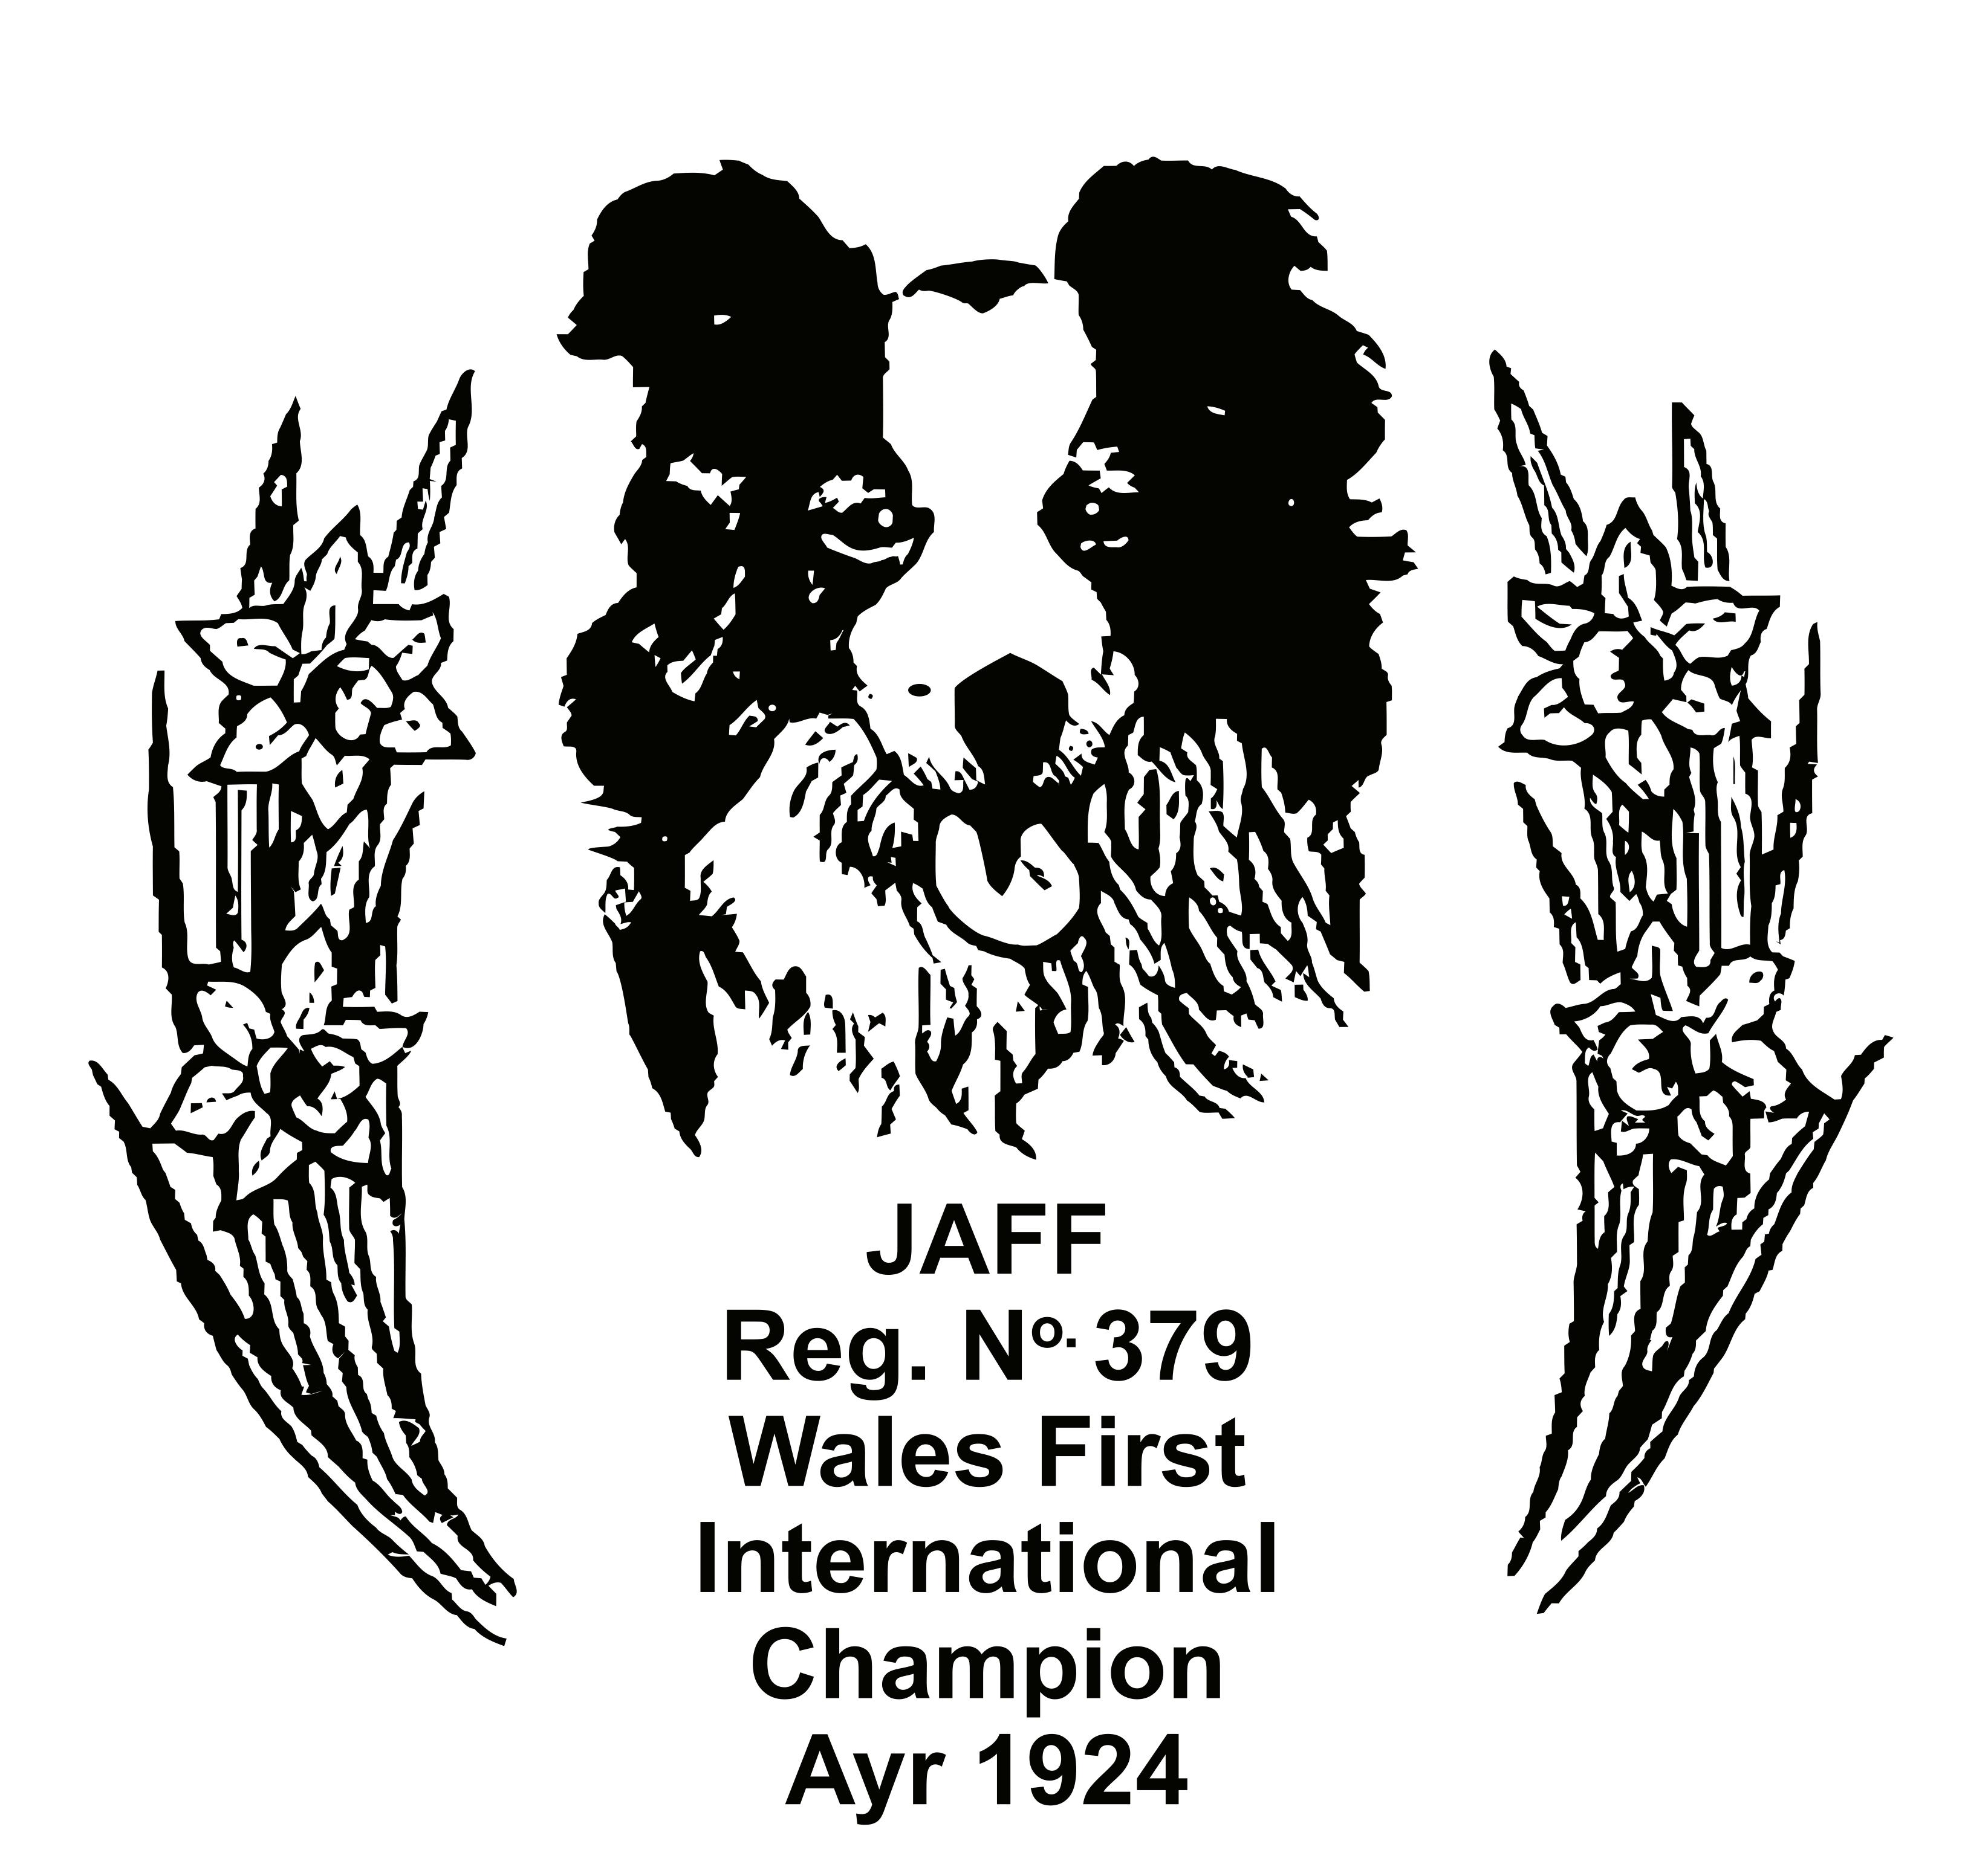

**NORTH WALES SHEEP DOG SOCIETY**

**COMPLAINTS PROCEDURE** (Jan.2019)

North Wales Sheep Dog Society aims to provide its members with the best possible service.

We positively welcome suggestions you may have for how we can improve our service.

Usually, a word with the person delivering one of our services will suffice. However, we recognise that from time to time there may be occasions when our members or indeed non-members feel that the quality or level of service / event provided falls short of what they could reasonably expect.

We also want to know about these occasions so that we can make good the problem and plan to avoid its repetition.

If you have a complaint, we would very much appreciate you telling us about it.

**This is what you should do:**

1. If you have a complaint to make, it should be made to the Society Secretary and Treasurer, who in the first instance, will try to resolve the issue informally.
2. If the issue is serious, or you are not satisfied after raising it with the Society Secretary and Treasurer, you should make a formal complaint.
3. Your complaint should always be made in writing/email, marked “private & confidential", signed and sent to the Society Secretary and Treasurer who will acknowledge it in writing/email, normally within 5 working days of receipt. Remember to keep a copy of your correspondence.
4. The Society Secretary and Treasurer shall, in consultation with the Chair of the Trustees Management Committee, investigate the complaint.
5. The Society Secretary and Treasurer shall communicate the results of the investigation to you within a reasonable time, normally 28 working days.
6. You have the right, if dissatisfied with the results of the inquiry, to put your case in writing/email or personally to a complaints panel. You must notify the Society Secretary and Treasurer within 14 days of being notified if you wish to pursue this course. The panel will comprise of three Trustees from the North Wales Sheep Dog Society Trustees Management Committee.

If attending personally, you have the right to be accompanied by a friend, interpreter, or non-legal advocate to help put your case. The complaints panel also has the right to have a nonlegal advisor present.

1. The decision of the panel will be final.
2. Where appropriate, North Wales Sheep Dog Society will make a written apology to the complainant and agree any further action necessary to make good the cause of the complaint.
3. All formal complaints and the response made to them will be recorded and filed in a secure place.
4. The North Wales Sheep Dog Society shall be informed by the Society Secretary and Treasurer at the first available meeting of the number and nature of any formal complaints and their outcome. Consideration will be given to the implications these have for the planning and management of future services.

* if a complaint relates to the Society Secretary and Treasurer, read Chair of the Trustees Management Committee.

**Timetable**

* Receive an acknowledgement normally within 5 working days
* Receive results of investigation normally within 28 days
* Request a hearing at the complaints panel within 14 days of being notified of results of investigation.

**Change record**

|  |  |
| --- | --- |
| **Date of change / Trustees approval** | **Changes / Comments** |
|  | To be reviewed January 2023 |
|  |  |
|  |  |